The steps of fig. 2

Step 1: Set the system operating conditions, select the fault size, fault location, system inertia level, damping level, etc., perform time-domain simulation offline, obtain big data samples, and build an input and output database.

Step 2: Preprocess the obtained input feature data and output feature data, and data preprocessing is to normalize the data to avoid some data affecting the weight due to excessive deviation. The normalized data conforms to the standard normal distribution with a mean of 0 and a standard deviation of 1, and can speed up the training and solution of neural networks and improve the calculation accuracy. The normalization conversion function is expressed as:



In the formula：  is the sample value,  is the mean of all sample data, and is the standard deviation of all sample data.

Step 3: Classify the data, In the formula 90% of the data is put into the training set for model training and 10% of the data is put into the test set to test the accuracy of the model.

Step 4: Set the number of network layers for the trained model, the number of neurons in each layer, the type of activation function, and the number of trainings.

Step 5: Start training and continuously train the weight matrix of the optimized iterative model so that the model loss function takes the value of the minimized value. The desired goal of this paper is to minimize the error between the predicted value and the actual value, that is, to minimize the mean squared error as the goal, and the mathematical expression of the mean squared error is:



In the formula: subscript  represents the actual value of the sample, and subscript  represents the predicted value of the sample.

Step 6: Complete model training, test with test set data, and perform error analysis.

For frequency-safe online analysis, it is first necessary to obtain the input feature dataset online, then input the input data into the trained deep neural network model, and finally output the frequency safety constraints and comprehensively perform the frequency safety analysis.

Equation：









































Figure:

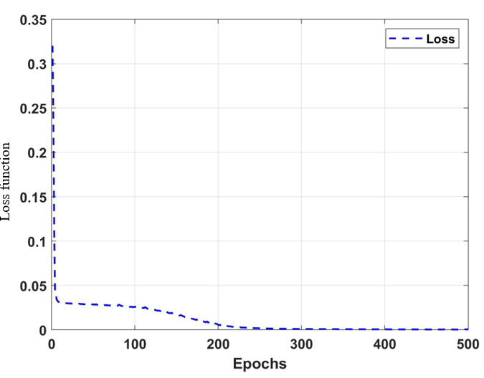

Fig.1 .Loss Function

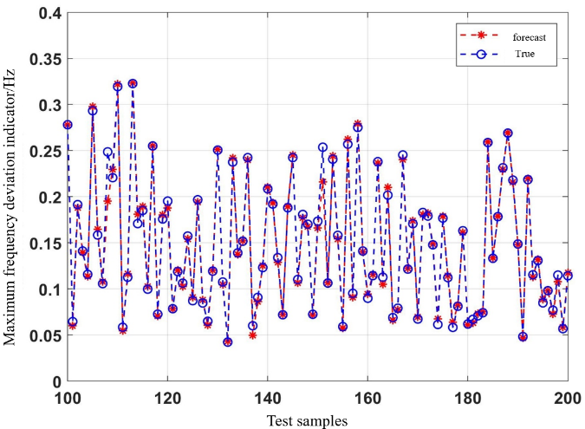

Fig.3a. Comparison of Frequency Deviation max

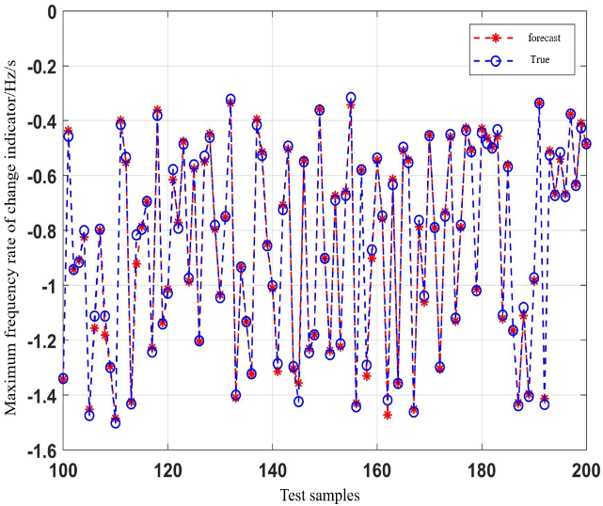

Fig.3b. Comparison of RoCoFmax

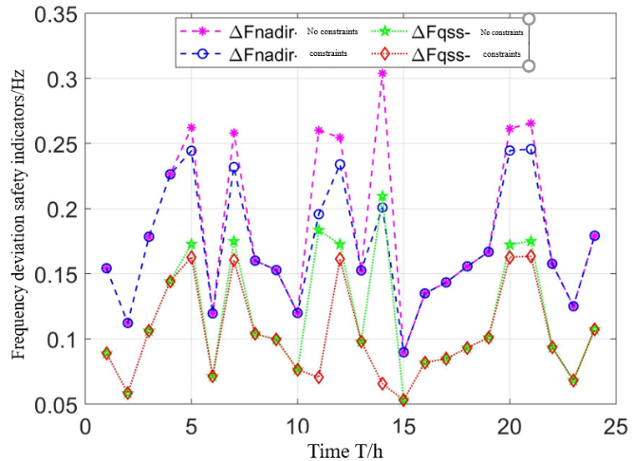

Fig.4a. Frequency Deviation Distribution When Considering Frequency Security Constraints

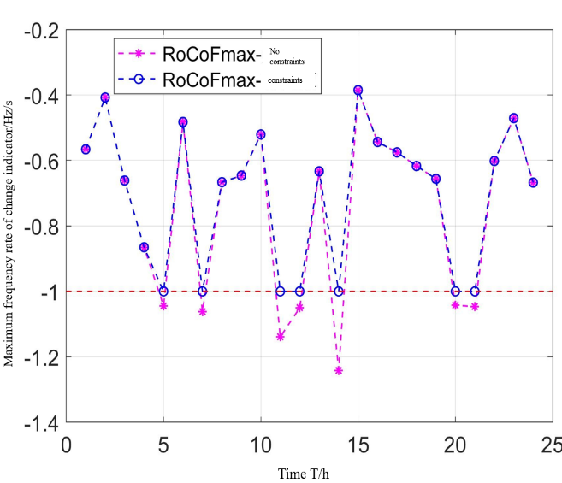

Fig.4b. RoCoF max Distribution When Considering Frequency Security Constraints

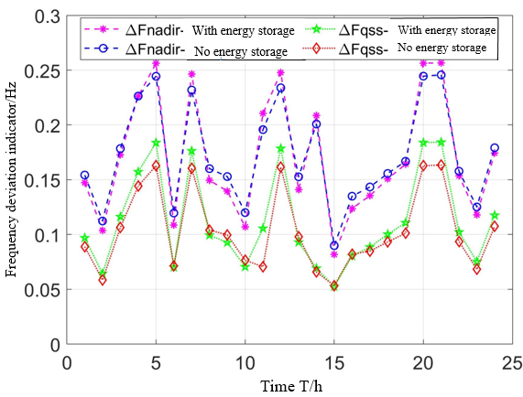

Fig. 5a. Frequency Deviation Distribution When Considering Dynamic characteristics of energy storage

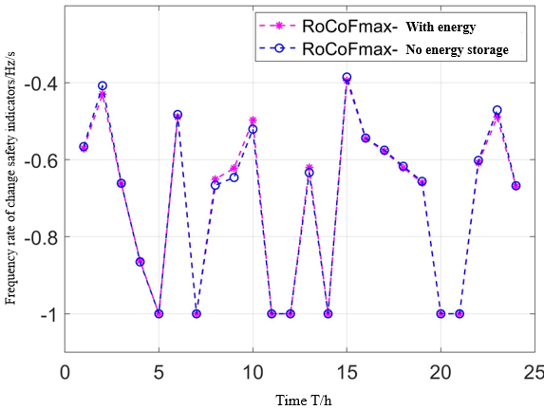

Fig. 5b. RoCoF max Distribution When Considering Dynamic characteristics of energy storage

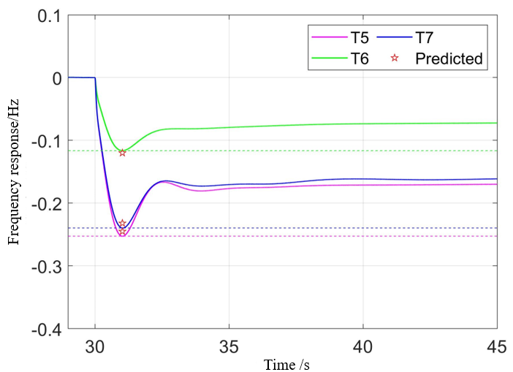

Fig. 6. Frequency Response.